**Wireframe**

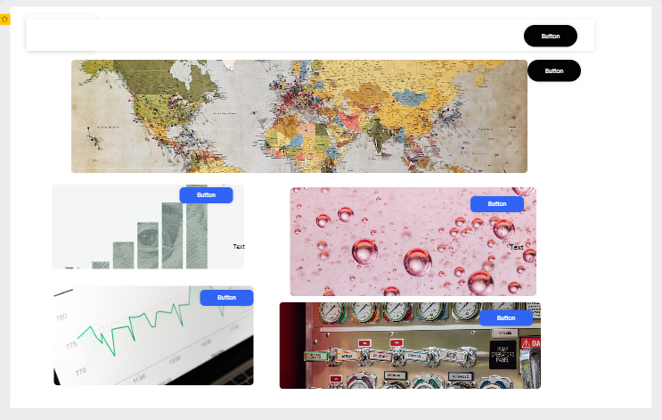

Please see link to the wireframe

<https://app.uizard.io/p/697aa865>